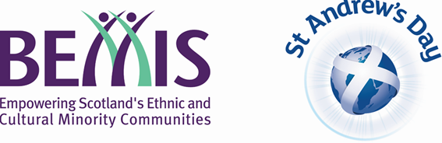

‘St Andrew’s Multi-Cultural Cup 2019’
1st December 2019, Toryglen Regional Training Centre

Application Form

1. Club/Group Details
Club/Group Name:
Club/Group address:
City: | Post Code:
Club/Group E-Mail Address: | Club Website:
Training Details:
Please Note: First 8 teams to be accepted will receive Adidas match tops*
Adults 16 years + (Max 10 players - All players must be 16 years +)
7 v 7 Game Format
Trophy presented to winning team

Youth’s 12 – 15 years (Max 10 players – All players must be between 12 – 15 years old – Mixed Gender)
7 v 7 Game Format
Trophy presented to winning team

Junior’s 8 – 11 years (Max 7 players – All players must be between 8 -11 years old – Mixed Gender)
4 v 4 Game Format
Participation Medals for all teams
2. What competition do you wish to enter? - If you wish to enter multiple teams – please complete additional application Forms
Please Note: First 8 teams to be accepted will receive Adidas match tops*
Please Note: First 8 teams to be accepted will receive Adidas match tops*
3. Who is the main contact for the organisation?
Title: | First Name: | Surname:
Position in Club/Group:
Address:
City: |  | Post Code:
Tel (Day): |  | Tel (Eve):
E-mail address:

Player Details
NAME | ADDRESS | POST CODE | DOB

Player Details- Further Information
NAME | Medical Conditions | Allergies | Please tick if player does not wish for Picture or  Video to be taken

Have you done everything?

To apply for a St Andrew’s Multi-Cultural Cup, you must be able to tick all the following boxes.

- You have completed all the relevant questions in this application form.
- Your club has relevant protection policies and has undertaken PVG checks for all coaches
- You have completed the player registration questions fully.
- You will abide to Scottish FA Codes of Conducts in regard to Coaches, Players and Supporters
- Your teams agree to wear Multi-Cultural Kit / Bibs during event

Closing Date:

4th November 2019
Please fully complete application form and return to Laura.Anderson@scottishfa.co.uk
or by post

Laura Anderson
Community Project Co-ordinator
Scottish FA
Hampden Park
Glasgow
G42 9AY

The Scottish FA and BEMIS Scotland will confirm your place within the St Andrew’s Multicultural Festival – Applying does not automatically grant your team a place within the festival

If you have any questions in regard to this event, please contact Laura.Anderson@scottishfa.co.uk
OR
Tanveer.parnez@bemis.org.uk

* Adidas Tops will be presented to teams on arrival to the Multi-Cultural Festival and only issued if they compete within competition – Tops must be worn during festival.

