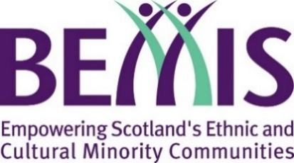
Scotland’s Winter Festivals 2020/2021

Multicultural Acts of Kindness Fund
For St Andrew’s Day 2020, we are encouraging local community groups to come together and celebrate Scotland’s national day by performing an act of kindness in their community – something that celebrates and promotes inclusion, diversity, and togetherness.
- Monday 30th November 2020 – St Andrew’s Day. Proposed activities can take place from 28th November to 30th November.
Organisations can apply for grants of up to £1,000 to help them with this. Note though that all proposals must adhere to all Scottish Government guidelines around COVID-19.
Please read the grant guidelines available at bemis.org.uk/swf/acts-of-kindness in full before completing this application form.
Please ensure you complete all the boxes and identify a contact that we can be in touch with regarding your application. Please note that submitting this form does not guarantee you will be awarded a grant.

About Your Organisation
Organisation Name
Contact Name
Contact Email
Contact Telephone No.
Website
Twitter
Facebook
Charity Number
(if applicable)
Tell us a bit about your organisation. Who are you, and what do you do?

Organisation’s Bank Details
Name of Bank
Name on your account
Sort Code
Account Number

Your Proposal:
Please summarise your proposed project or activity (150 words max):
Proposed Date of activity
Must be Sat 28th, Sun 29th, or Mon 30th November
Beneficiaries
Who will your proposed project help or benefit?
Please also give an estimate of the number of people.
Expected Diversity
Which cultural communities do you expect to participate in and benefit from this project?
Budget
Please give us a breakdown of your proposed budget for this project.
The grant requested from BEMIS Scotland must also be itemised and broken down. Requests for block figures with no budget breakdown will not be considered
Total Requested

We acknowledge that we must record details of all people directly benefitting from this project  It is a condition of the grant that submitting evaluation form is essential. Failure to submit an evaluation for your event will entail failure to adhere to the grant’s conditions and consequently an obligation to return the grant to BEMIS. | ☐  Tick to Agree

St Andrew’s Fair Saturday
From 28–30 November 2020, Scotland is joining the celebration of Fair Saturday as part of the wider celebration St Andrew’s Day and everyone is invited to take part in St Andrew’s Fair Saturday.
Please see the programme guidance for more information about St Andrew’s Fair Saturday.
https://standrews.fairsaturday.org/
We agree to be part of the St Andrew’s Fair Saturday programme | ☐

Submitting Application
Please return this completed form to:
festivals@bemis.org.uk

Contact
If you have any queries please get in contact by emailing festivals@bemis.org.uk
You can also follow us on Twitter @bemis_scotland

