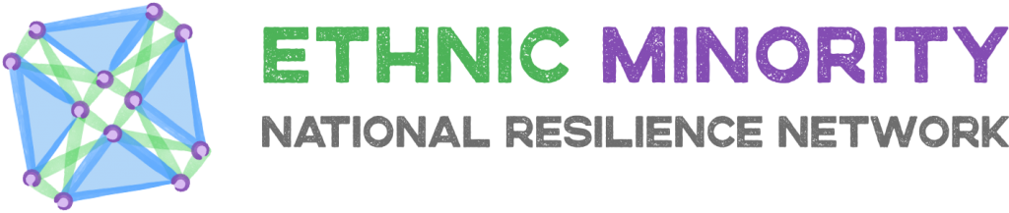

THEMATIC SUBGROUP MEETING NOTES

Group | Collaboration and Sustainable Support
Chairperson / Organisation | Nina Munday
Date of meeting | 8th October 2020

Attendees

Danny Boyle – BEMIS
Patricia Iredia – African Caribbean Women’s Association
Tanveer Parnez – BEMIS
Nina Munday – Fife Centre for Equalities
Ephraim Borowski – SCOjEC
Sarah Kwan - ESAS
Kris Chapman – Action against Prejudice
Kimi Jolly – ESAS
Habib – Aberdeen Multicultural Centre
Noelia Martinez – Citizens Rights Project
Davie Donaldson – Progress in Dialogue
Margaret Lance – Women in Action
Yen Nalci – Dumfries and Galloway Multicultural Centre

Meeting Note:
Nina Munday gave an introduction on the broad aims of the group.

Group members were invited to introduce themselves.

Rakiya Sulieman – Rakiya, originally from Nigeria, is equalities advisor for NHS Lothian. Prior to that she was a clinical nurse. She promotes equality in NHS Lothian. This includes a staff network. The BME staff network and others help staff to understand their rights regardless if they are members of a union or not. Rakiya shares learning internally and externally with NHS from an equalities and human rights perspective.

Kris Chapman: Youthlink Scotland. Working on the Action on Prejudice project. The aim of project is an information / intelligence website on issues going on in Scotland and helping communities to respond to hate crime issues in Scotland. This includes reporting, challenging hate crime by calling it out, 3rd party reporting or liaising with Police Scotland. AOP can share support to the network on their website of issues that affect them.

Ephraim Borowski: SCoJEC and BEMIS. SCoJEC support jewish communities across Scotland.

Margaret Lance: Works for Waverly Care that supports people living with HIV and Hepatitis C. These issues are very sensitive topics. Other people in communities have underlying issues in their communities. Women in Action is a voluntary organisation to support women and empower them to reach their potential and deal with serious issues like NRPF, Domestic Violence and other issues that they require unique support for.

Noelia Martinez: Citizens Rights Project main focus is proving support advice and information to EU nationals who face challenges in respect of BREXIT. Time is coming close for the EU re-settlement scheme and CRP have significant concerns about the rights of these individuals and communities over the next 9 months. Huge concerns about Non-EU citizens and 3rd country nationals who are reliant on citizenship connections with EU nationals who have been partners. CRP developing a database of organisations to ensure additional support clients needs can be signposted too. Particularly around language support.

Davie Donaldson: Project Director at Progress in Dialogue. Supports lots of different communities. Bringing together marginalised groups empowers them to stand together in times of difficulty. Over lockdown their focus has been of trans and gypsy traveller communities. Socio-economic intersection receives focus as this exacerbates inequality. We are also support communities through hate crime reporting. Our coming priorities are shaped by pandemic and impact on grassroots communities. Their voices cannot be drowned out. Hate Crime hasn’t went away and we need to continue to understand and challenge it. Gyspy Travellers facing increased issues due to Covid. Turned away from services. BLM and other social justice campaigns are an important platform to challenge inequalities.

Sarah Kwan: ESAS set up to respond to hate crime increase in their communities as a result of COVID and affectively engaged with EMNRN to try and respond to these issues.

Habib Ashan: Working in Aberdeen to respond to issues in their communities.

Kimi Jolly: ESAS – working with these communities who are experiencing hate crime due to COVID.

Yen Nalci: Dumfies and Galloway update – significant challenges to socio / economic disadvantage and progressing community support via funding support and EMNRN.

Patricia Iredia: Nigerian, doctorate in Educational Psychology. Also chair of ACWO. 30 years old and sickle cell awareness. First organisation to do this. African communities remain significantly affected by ongoing pandemic.

Tanveer: Update on BEMIS funding and ongoing community support.

Danny: Update on Hate crime and next steps. Hate crime response and EU re-settlement scheme response.

The group discussed the issues of hate crime within the context of Black Lives Matter, the Pandemic and ongoing challenges to seek affective and reasonable time responses to these key issues affecting people daily. It was agreed.

Three key action points:

- Invitation to Scottish Government to share their findings on deep dive hate crime report
- Invitation to a Senior Police Officer to hear people’s stories
- A national campaign for people to share their stories with the wider public be it video, anonymised text, written story, voice recording or other format.

Date of next meeting:
Wednesday the 25th of November 2020 10:30 am.

