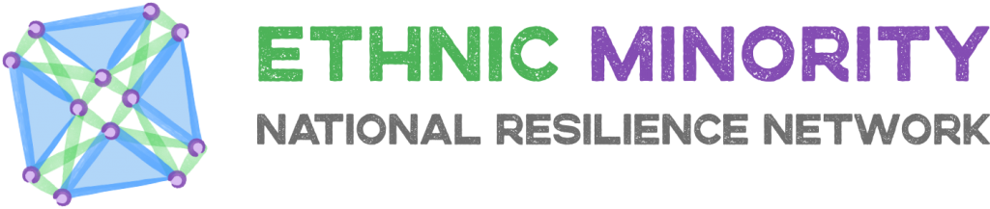
The key goals of Ethnic Minority National Resilience Network are:
- Intelligence and Signposting: Ensure ethnic minority (EM) communities are engaged with local support networks and services.
- Responding and Providing: Provide EM communities with emergency food funds for vulnerable families if and when required.
- Inclusive and Receptive Approach: Develop and all-encompassing approach to ensuring EM individuals, families and local communities are resilient and supported equally.
To help achieve the goals, a number of subgroups have been set up. Enhancing Collaboration Subgroup is one of these subgroups.

Enhancing Collaboration Subgroup
Collaboration means 'to work with another person or group in order to achieve or do something'.
In the context of community response to COVID 19 it means we, as organisations need to find innovative ways of working together, supporting each other and engaging with the broader public, third and even private sector to make sure or members and communities are supported through this challenge.
We are already collaborating as a network. We engage at meetings, offer advice and mutual support and empower local organisations to respond to issues in their communities.
Can we do more?
There are lots of brilliant national and local organisations we can learn from or link into. We need to do this strategically across the core areas of interest.
Examples:
- Challenging hate crime
- Providing emergency sustenance support
- Accessing mental health services
- Accessing victim support

Aim of next collaboration meeting
We need to identify the core areas of interests for members and their communities. What are our priorities and how can we get there?
- Identify core themes
- Identify potential partners or organisations, services we need to learn from or engage with
- Invite them to attend and engage at future meetings
Questions:
- What is your communities 2 key priorities in the next 6 – 12 months?
- Who do we need to speak too or ask to engage with to help make this happen?
- What collaborations do we need to enhance to support the goals of the national resilience network?

