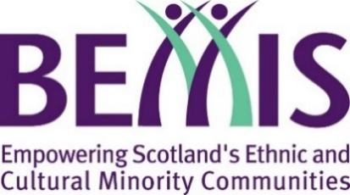
Scotland’s Winter Festivals 2020/2021

Burns Day Fund
BEMIS Scotland are calling our communities to begin 2021 with a positive celebration of Burns Night:
- Monday 25th January 2021 – Burns Day. Proposed activities can take place from Friday 22nd January to Sunday 31st January.
Organisations can apply for grants of up to £1,000 to help them with this. Note though that all proposals must adhere to all Scottish Government restrictions and guidelines around COVID-19 (available here).
Please read the grant guidelines available at bemis.org.uk/swf/acts-of-kindness in full before completing this application form.
Please ensure you complete all the boxes and identify a contact that we can be in touch with regarding your application. Please note that submitting this form does not guarantee you will be awarded a grant.

About Your Organisation
Organisation Name
Contact Name
Contact Email
Contact Telephone No.
Website
Twitter
Facebook
Charity Number
(if applicable)
Tell us a bit about your organisation. Who are you, and what do you do?

Organisation’s Bank Details
Name of Bank
Name on your account
Sort Code
Account Number

Your Proposal:
Please summarise your proposed project or activity (150 words max):
Proposed Date of activity
Must be between Friday 22nd and Sunday 31st January.2021
Beneficiaries
Who will your proposed project help or benefit?
Please also give an estimate of the number of people.
Expected Diversity
Which cultural communities do you expect to participate in and benefit from this project?
Budget
Please give us a breakdown of your proposed budget for this project.
The grant requested from BEMIS Scotland must also be itemised and broken down. Requests for block figures with no budget breakdown will not be considered
Total Requested

We acknowledge that we must record details of all people directly benefitting from this project  It is a condition of the grant that submitting evaluation form is essential. Failure to submit an evaluation for your event will entail failure to adhere to the grant’s conditions and consequently an obligation to return the grant to BEMIS. | ☐  Tick to Agree

Submitting Application
Please return this completed form to:
festivals@bemis.org.uk

Contact
If you have any queries please get in contact by emailing festivals@bemis.org.uk
You can also follow us on Twitter @bemis_scotland

