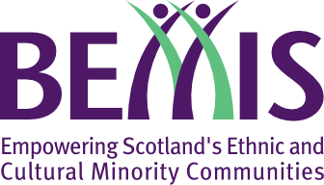
Vaccine Information Fund
Application Form
Grants of up to £1,500 are available for charities and constituted community organisations to hold engagement sessions and create information resources for their community to help develop a fully informed consent for the Covid-19 vaccination programme among their members, until March 2022.
Before completing this application, please read the full guidelines which are available on our website at bemis.org.uk/vif

Note: All activities must comply with all relevant Covid-19 social distancing rules, which can be found at https://www.gov.scot/coronavirus-covid-19/

Organisation name
Lead contact name
Lead contact email
Lead contact phone number
Charity Number
(if applicable)
Website
Social Media links
(e.g. Twitter, Facebook)
Where is your organisation based?
E.g. which town, city, or area within a city

Bank account details
Name of bank
Name on Account
Sort Code
Account Number

Your Proposal
Please summarise your proposed project or activity
Would you like the help of an outside expert?
We may be able to help invite along health professionals with an expertise in the COVID19 vaccine to answer questions or be part of a discussion?
Beneficiaries
Who will your proposed project help or benefit?
Which ethnic and cultural communities do you expect to reach?
Please give an estimate of the number of people.
Proposed date(s) for activities
If you do not know yet, please provide a rough estimate of when you might be running these activities

Budget
Please provide an itemised budget for your project (breakdown of costs)
Total requested

Confirmation (required)
☐ I acknowledge that we will be required to submit a brief report and case study upon completion of the programme
☐ I confirm that the above organisation is constituted and eligible as per the grant guidelines, and that I am authorised to make an application on its behalf
☐ I confirm that I have read the grant guidelines and that we will fully adhere to them

Submission
Please submit this completed application form by email to:
vif@bemis.org.uk
If you do not receive a confirmation of receipt and an application number within 3 working days, please contact us at mail@bemis.org.uk.

