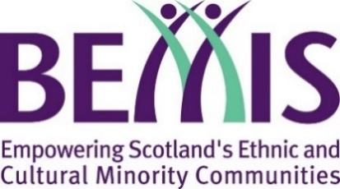
Scotland’s Winter Festivals 2021/2022

Application Form
The 2021/2022 SWF fund is focused on two celebrations:
- St. Andrew’s Day (Events from Friday 26th to Tuesday 30th November 2021)
- Burns Night (Events from Friday 21st to Tuesday 25th January 2022)
Organisations can apply for grants of up to £2,000 to help host an event. Note though that all proposals must adhere to all Scottish Government guidelines around COVID-19.
Please read the grant guidelines available at bemis.org.uk/swf in full before completing this application form.
Please ensure you complete all the boxes and identify a contact that we can be in touch with regarding your application. Please note that submitting this form does not guarantee you will be awarded a grant.

About Your Organisation
Organisation Name
Contact Name
Contact Email
Contact Telephone No.
Where is your organisation based?
E.g. which town, city, or area within a city
Website
Twitter
Facebook
Charity Number
(if applicable)
Tell us a bit about your organisation. Who are you, and what do you do?

Your Proposal:
Event title
Proposed Date
Proposed Venue
(include address if possible)

Please summarise your proposed project or activity (150 words max):
Beneficiaries
Who will your proposed project help or benefit?
Please also give an estimate of the number of people.
Expected Diversity
Which cultural communities do you expect to participate in and benefit from this project?
Budget
Please give us a breakdown of your proposed budget for this project.
The grant requested from BEMIS Scotland must also be itemised and broken down. Requests for block figures with no budget breakdown will not be considered
Max: £1500
Total Requested

St Andrew’s Fair Saturday
From 26–30 November 2022, Scotland is joining the celebration of Fair Saturday as part of the wider celebration St Andrew’s Day and everyone is invited to take part in St Andrew’s Fair Saturday.
If you agree, your event will also be added to the Fair Saturday programme. Please see the programme guidance for more information about St Andrew’s Fair Saturday.
https://standrews.fairsaturday.org/
We agree to be part of the St Andrew’s Fair Saturday programme | ☐

Organisation’s Bank Details
Name of Bank
Name on your account
Sort Code
Account Number

Submitting Application
Please return this completed form to:
swf@bemis.org.uk

Deadline
- For St Andrew’s Day events: Friday 19th November 2021
- For Burns Night events: Monday 17th January 2022

Contact
If you have any queries please get in contact by emailing swf@bemis.org.uk
You can also follow us on Twitter @bemis_scotland

