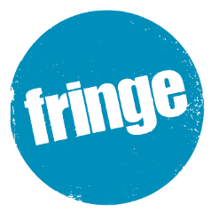
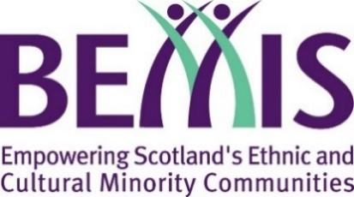
Scotland on Tour Community Fringes 2022

Application Form
This year, Scotland on Tour is teaming up with The Edinburgh Festival Fringe Society to celebrate the 75th anniversary of the Edinburgh Fringe. We are giving 10 communities across Scotland the unique opportunity to participate in this celebration through the creation of their own Fringe event. 10 Community Fringe events are proposed take place over two weekends in September 2022.
You can apply for a grant of up to £5,000 to host one of these events.
Please read the grant guidelines available at bemis.org.uk/fringe in full before completing this application form.

About Your Organisation
Organisation Name
Contact Name
Contact Email
Contact Telephone No.
Where is your organisation based?
E.g. town or city
Website
Social media
(Twitter, Facebook, Instagram etc.)
Charity Number
(if applicable)
Tell us a bit about your organisation. Who are you, and what do you do?
What experience do you have running in running events?

Your Proposal:
Event title
Proposed Date
(A weekend in September)
Proposed Venue
(include address if possible)

Please summarise your proposed event
Including an idea of proposed artists/performers and any other proposed activities
Expected Attendance
Expected Diversity
Do you expect to work with or attract any particular ethnic and cultural minorities?
Budget
Please give us a breakdown of your proposed budget for this project.
The grant requested from BEMIS Scotland must also be itemised and broken down. Requests for block figures with no budget breakdown will not be considered
Max: £5000
Total Requested

Organisation’s Bank Details
Name of Bank
Name on your account
Sort Code
Account Number

Submitting Application
Please return this completed form to:
fringe@bemis.org.uk

Deadline
The deadline for applications is Sunday 31st July 2022.

Contact
If you have any queries, please get in contact by emailing fringe@bemis.org.uk

